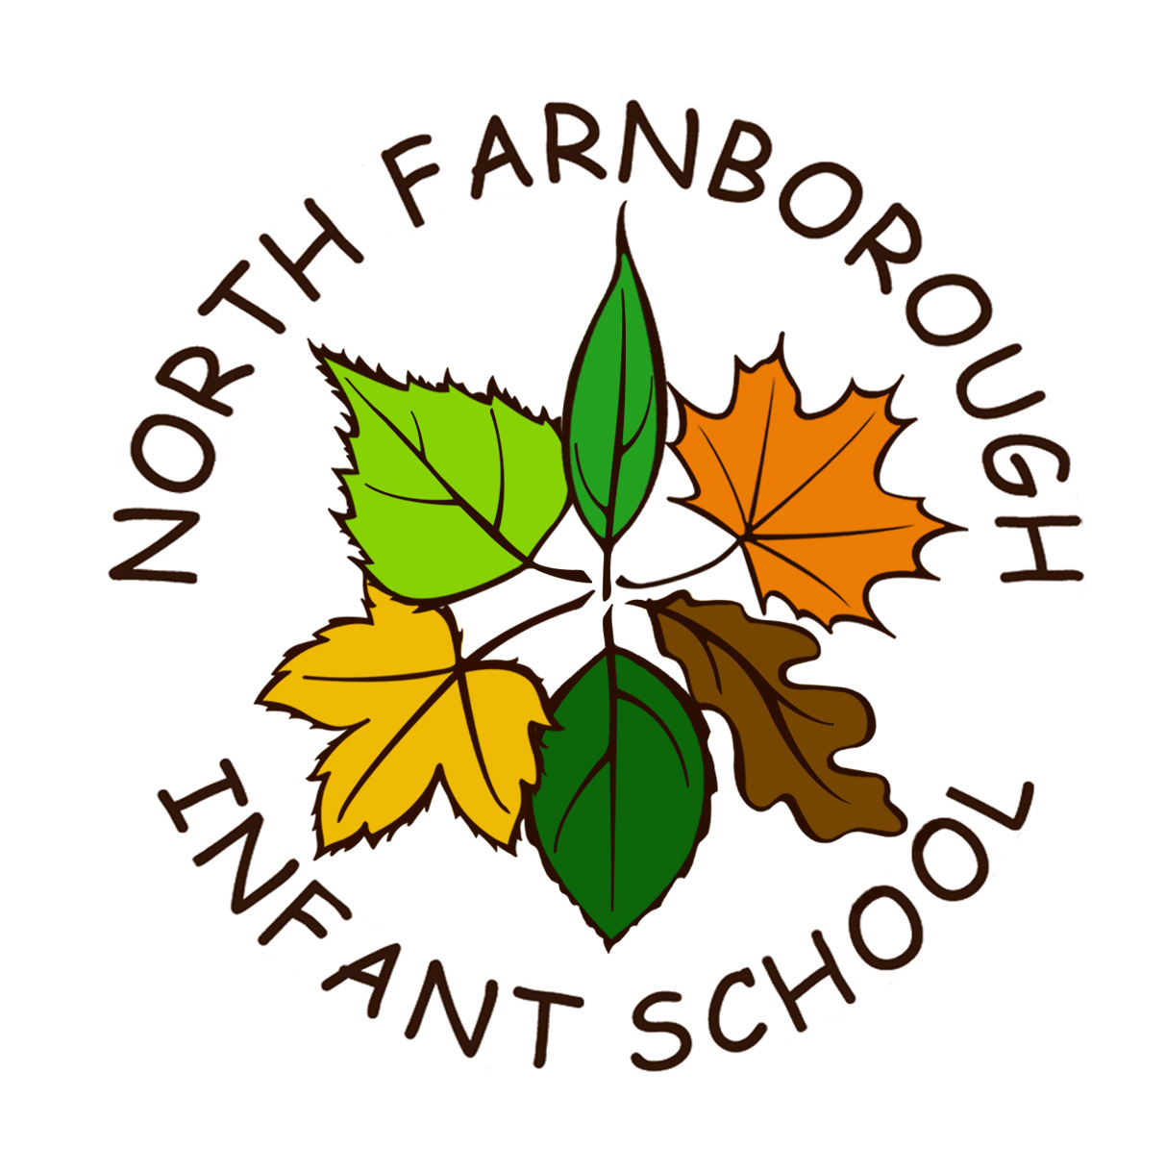
North Farnborough Infant School Rectory Road, Farnborough, Hants GU14 8AJ

Telephone: 01252 544606
www.nfis.hants.sch.uk
email: adminoffice@nfis.hants.sch.uk

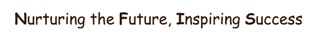

Head teacher – Miss Abigail Morgan

SECOND HAND UNIFORM
We have good quality second hand uniform for sale in varying sizes. If you need any uniform during the school year, please complete the order form and drop it into the school letterbox outside main entrance.
We will fulfil your order within 7 to 10 working days, and will contact you when it is ready to collect. Payment is made, via Arbor, in the School Shop option, once you are satisfied that the item is suitable. If not suitable then return it to the school office.
If you would like to donate your child’s old school uniform to raise funds for the school, please make sure that it is washed, with all name labels removed. Please leave it at the school office.

Child's Name:
Class:
Item | Price per item | Size | Quantity
Red Cardigan | £2.00
Red Sweatshirt | £2.00
Grey Trousers | £2.00
Grey Skirt | £2.00
Grey Pinafore Dress | £2.00
Red & White Dress (Summer only) | £2.00
Grey Shorts  (Summer only) | £2.00
Red PE T-shirt | £2.00
Navy PE Shorts | £2.00
PE Bag | £2.00
School Bag | £2.00

